✅ 1. Select all fields from Customers table  
✅ 2. Select different countries from Customers table  
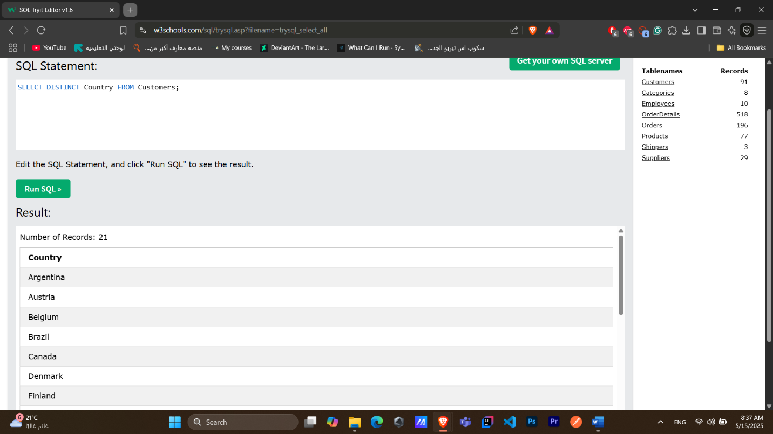

✅ 3. Select different CustomerName, ContactName, Address from Customers table

✅ 4. Select all customers from Mexico

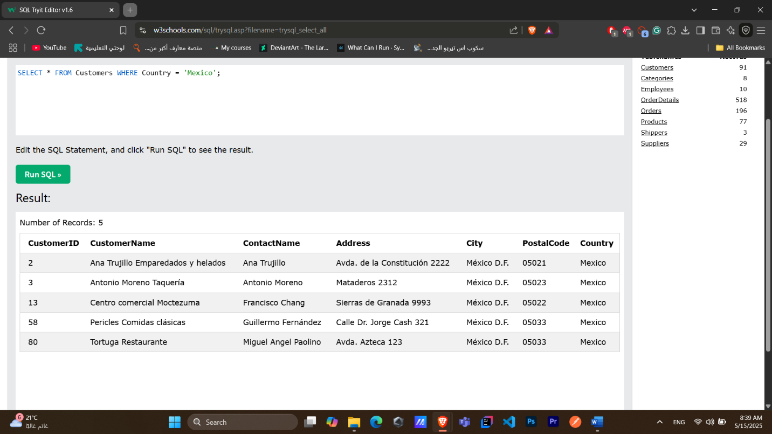

✅ 5. Select specific fields when ContactName is Ana Trujillo  
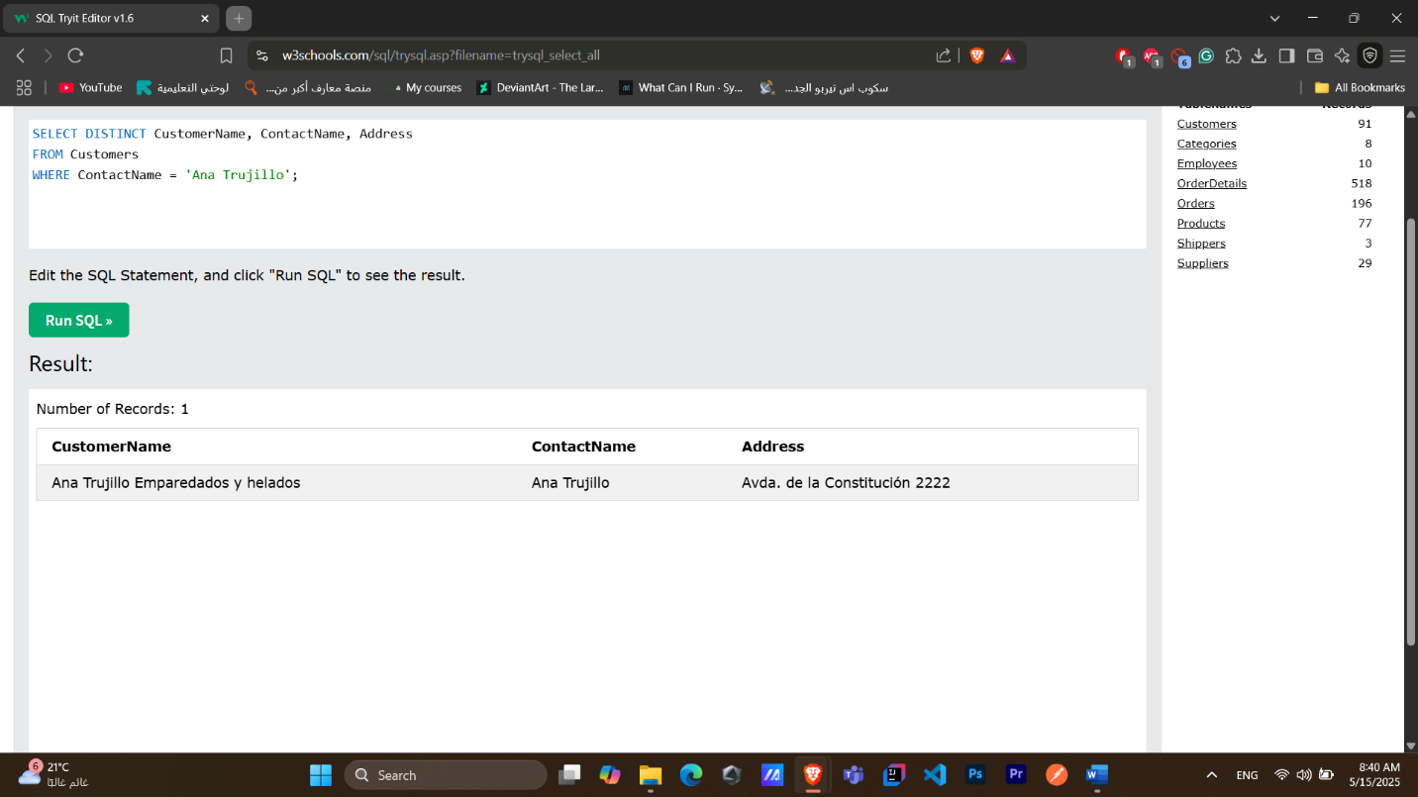

✅ 6. Select all from Products ordered by price ascending  
✅ 7. All customers from Spain whose name starts with 'G'  
✅ 8. All customers from Germany or Spain

✅ 9. Find maximum price in Products  
✅ 10. Sum of Quantity in OrderDetails  
